Portrait Photography Research
- Brett Henrikson
- Where/when he/she was born, where they live now if alive: Brett lives in Pawtucket, Central Falls and has a studio there where he develops his photographs in a darkroom.
- where they studied photography and how they got their start in photography: The Rhode Island School Of Design, (2007-2011) BFA Photography
- what they do or did for a living in addition to photographing: Teacher at Rhode Island School Of Design for dark room
- What influenced the photographer: hands on aspects of working in the darkroom and using film or large format gives the artist a real sense of creation over their work
- what motivates him/her to shoot what they shoot
- what is the focus of his/her work: intersection of life and death
- What is the work about or what is it communicating: His interests over the past few years have ranged from traditional photographic projects to works which have pushed the medium into directions either away from the realistic aspects of photography or towards the creation of constructed realities. He has done to through the use of manipulating the collodion medium and fighting the precious treatment of film objects
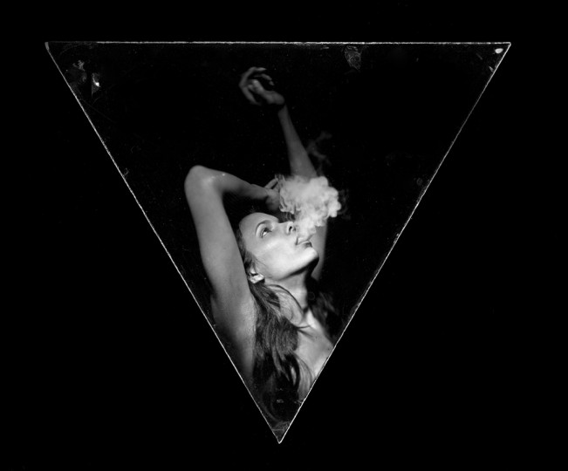
Works:
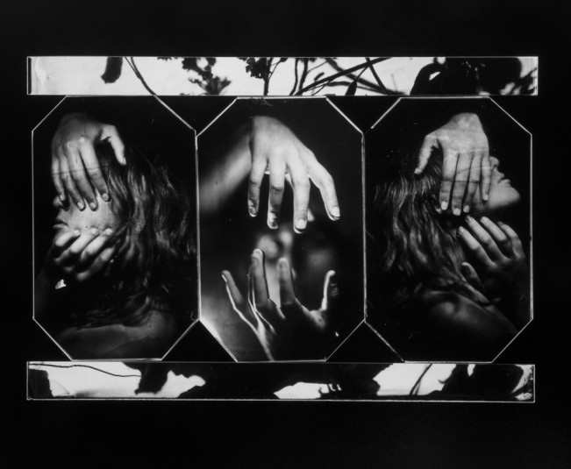

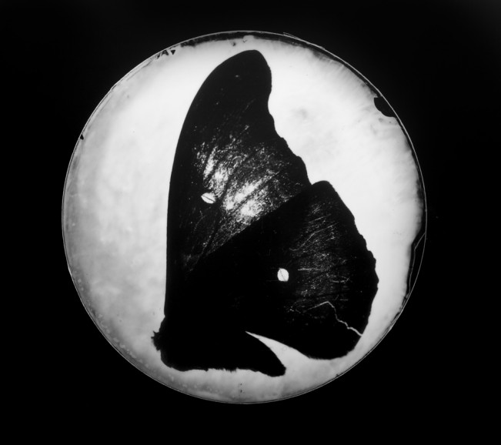
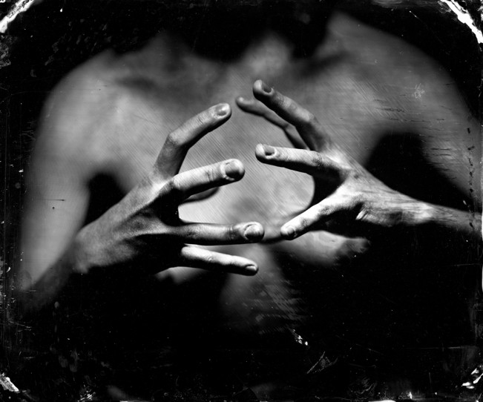

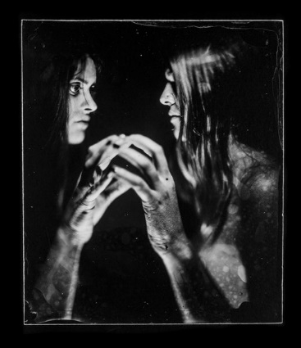

Artist: Mark Seliger
· where/when he/she was born, where they live now if alive: born in Amarillo Texas in 1959, then moved to Houston
· Where they studied photography and how they got their start in photography: East Texas State University, studied history of documentary photography
· What they do or did for a living in addition to photographing (if anything): he began shooting small assignments for Rolling Stone magazine and co-directed numerous music videos
· what influenced the photographer: his interest in photography started when his brother Frank promised to give him his Diana camera if he got a base hit in the little league.. Which he did. He began to fall in love with printing and developing photographs in his family's bathroom.
· What is the focus of his/her work: Fashion, lifestyle, and candid mainly focused on shooting famous celebrities
· What is the work about or what is it communicating: capturing the beauty of fashion and artists personalities
Artwork:

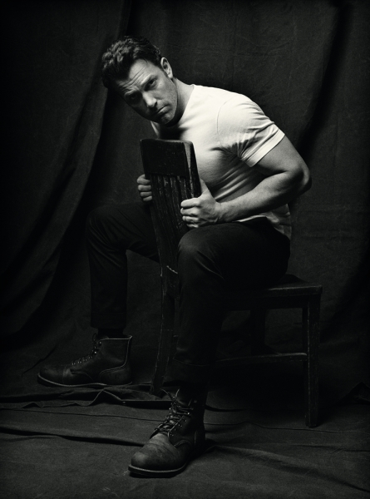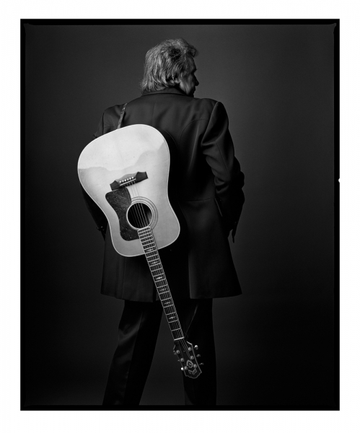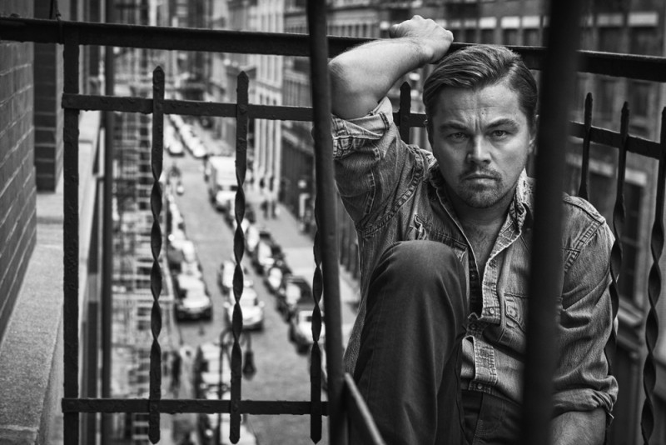
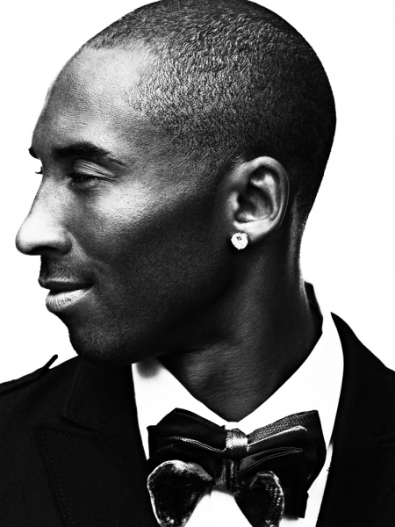

Artist: Charles H. Traub
- where/when he/she was born, where they live now if alive: Charles was born in Louisville Kentucky in 1945.
- where they studied photography and how they got their start in photography: He studied English literature at the University of Illinois and then joined the Peace Corps after graduation in 1967.
- what influenced the photographer: Aaron Siskind, Arthur Siegel, and Garry Winogrand influenced Charles they all focused on abstracted black and white landscapes
- what is the focus of his/her work: to capture the busy life and culture of other
- what is the work about or what is it communicating: his first major body of color work, Street Portraits, which he continued after moving to New York City in 1978. For the past four decades, he has worked exclusively in color and was an early proponent of digital imagery.
Artworks:

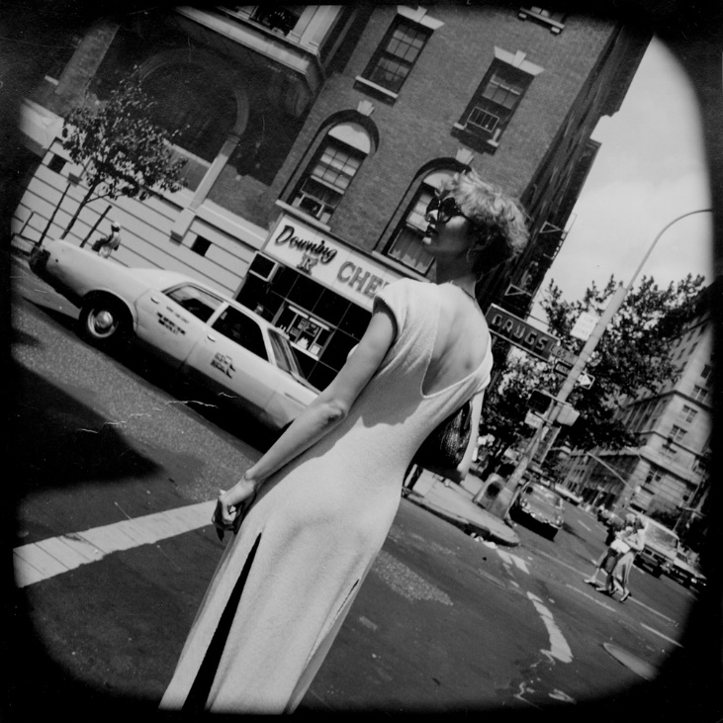
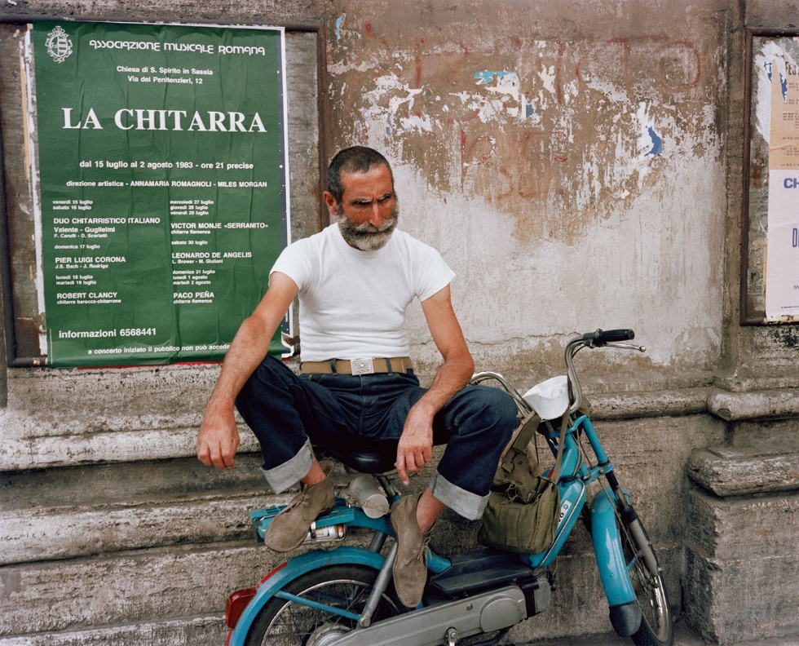0